Jenkins Configuration

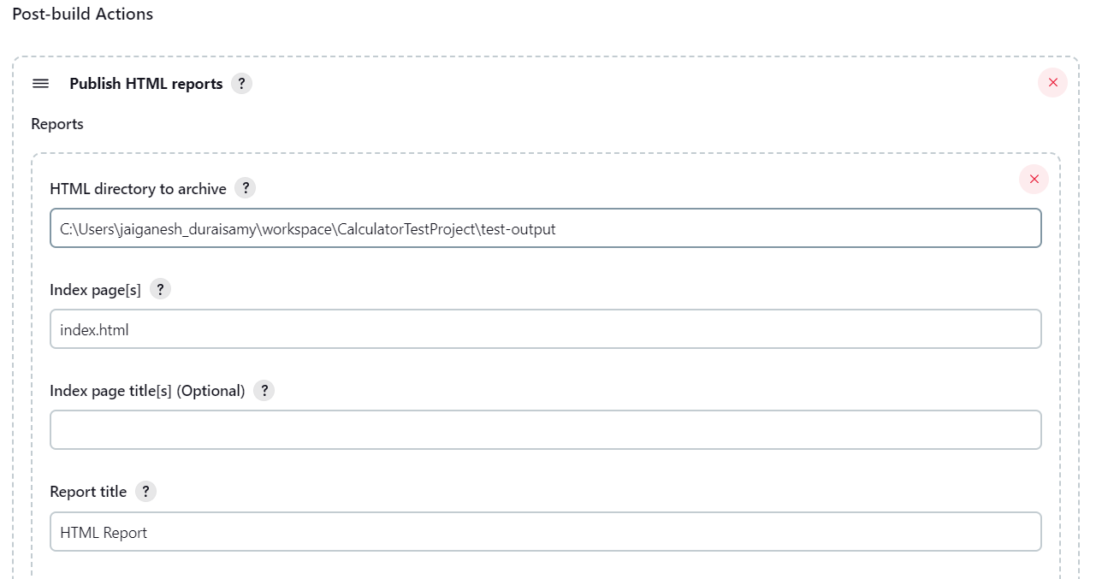

URL: <http://localhost:8080/job/CalculatorTestProject/HTML_20Report/>

